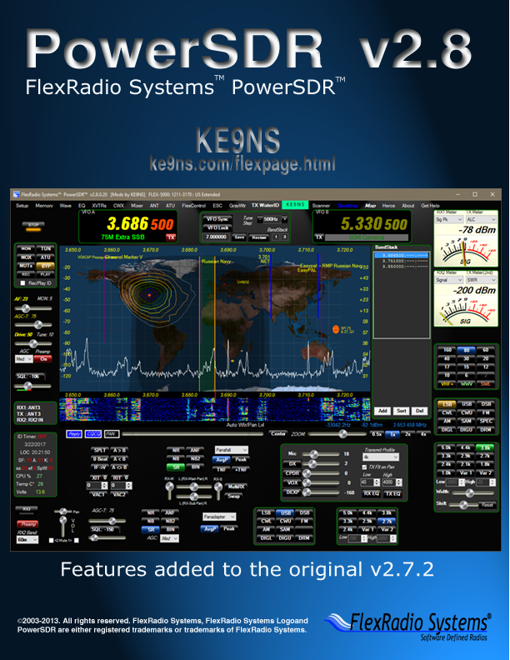

V2.8.0.49

**“Spotter” window (top of PSDR console screen):**  
- **DX Cluster** (from a list of up to 10 URL address’s as URL:port )   
- Automatic parsing of Cluster information to deduce Mode, Split  
- Determine DX Country and location (based on included dxloc.txt file)  
- Automatically Manage Age of DX spots and update the spotter, checking for dups, etc.  
- Automatically compute Antenna rotor angle of DX station relative to your station lat & long  
  
- Left Click on any DX spotter line to go directly to Freq, Mode, Split of DX station  
- Left Click on any DX spotter line “rotor angle°”, and you also send an Antenna rotate command to DDUtil to move your Antenna. (see rotor setup example at ke9ns.com/flexpage.html)  
- Right Click on DX spotter line to open up QRZ.com page for DX spot

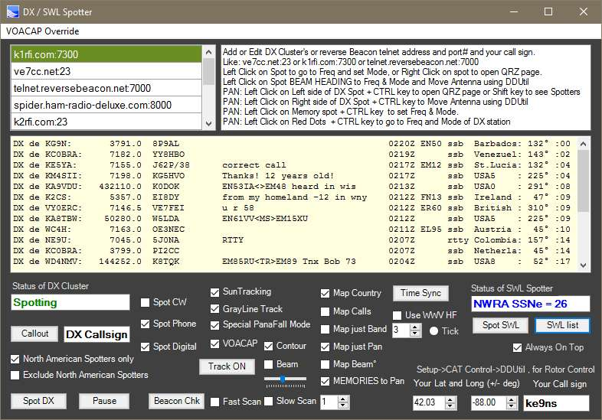

Post DX spot contact via the Spotter "Callout" button (i.e. Post your contact to the Dx cluster directly from PowerSDR) Two ways to Post a contact: 1) Make a contact, type in the contacts Callsign in the "DX Callsign" box and hit Post, then confirm YES to the pop-up message box. 2) Select a DX spot from the DX Spotters list, make contact, then hit Post (leave the DX Callsign box alone), it will use the highlighted DX contact as the callsign. Within a few seconds, you will see your post appear at the top of the DX Spotters window.Note: The DX Cluster must be active and running in order to Post to the Cluster. Also, your posting under your Callsign as the Spotter.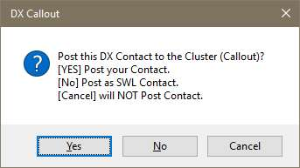

- **DX spots appear as Markers along the Panadapter window** (with **Green lines**)  
- **Left Click + CTRL** on a DX Spot Callsign (in Panadapter) will set Radio to that DX stations Frequency, Mode, Split, and **Highlight** that stations Line in the DX spotter window for easy identification in the spotter window.  
- **Left Click + CTRL on the last letter** of the DX Spot Callsign will not only set the Radio, but send a Rotor Antenna move command.  
- **Right Click** on a DX spot Callsign (in Panadapter) to open up QRZ.com page  
- **Shift key** (while PSDR is in Focus) switches DX spots to DX Spotters, and brings up a Lat & Long grid.  
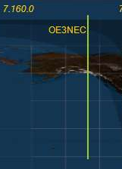

- **Memory to Pan** (checkbox) places your memory list onto the Panadapter (with **Blue lines**)  
- **Left Click** on **Memory** in panadater, hit CTRL key, to go to that freq, mode, split, filters, etc.  
- **Right Click** on **Memory** to open up a URL Address (web page) that you place in the Memory Comments field. (example: http://www.vk3evl.com/index.php?option=com_content&view=article&id=57&Itemid=62)  
The above example would take you to the Easypal download web page.  
 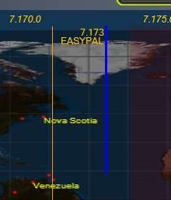

- **Spot SWL** places ShortWave Stations (described in detail down below) onto the Panadapter (with **Purple lines**)  
- **Left Click** on **SWL Spot** in panadater, hit CTRL key, to go to that freq, mode.   
- **Right Click** on **SWL Spot** to Google Search the Name of the ShortWave Station.  
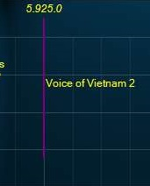

- **World Map** (**Equirectangular projection embedded into PowerSDR) with special 80/20% Panafall mode.   
- True Sun position (based on time and date) including solar weather data.  
- True Moon position (based on time and date) including Beam heading and Elevation angle.  
- True ISS (International Space Station) using Internet data, including Beam heading and Elevation angle. Along with dots showing the ISS positon over the next 20 min.  
- True Grayline (with Sunset and Dusk areas): (based on time and date). Right click on CENTER button to adjust color and transparency.  
- DX Spots appear on World Map as Red Dots in their correct locations (options to show country or Callsign).  
- Left Click (to focus PSDR), then hit CTRL over any Red Dot to go directly to DX spot freq, mode, split  
- Option to map spots on map for your current Band, or current Pan**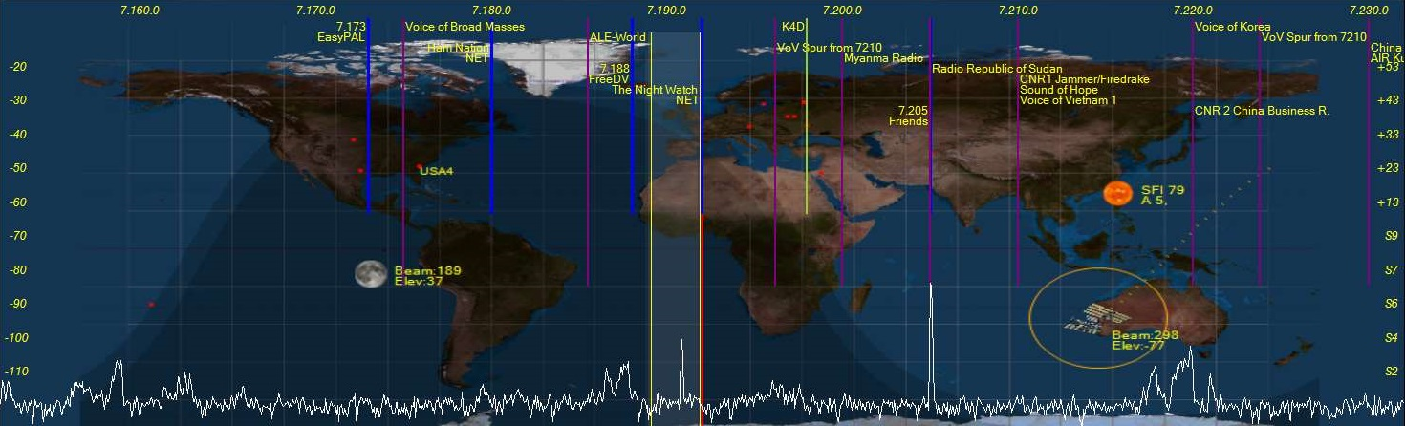

**- VOACAP propagation mapping. Automatically compute propagation conditions, based on current solar weather data, using the Effective SunSpot#. Map changes based on power level slider (up to 1500w). Default is 35’ Dipole or optional 35’ 3 ele Yagi antenna checkbox.   
- Display Propagation map as dots (the larger the dot the stronger the signal a person under the dot would receive from you. (Gray = S1-S2, Orange=S3-S4, Yellow=S5-S6, Green=S7-S8, Blue = S9-S9+)  
- Display Propagation map as Contours (Gray = S1-S2, Orange=S3-S4, Yellow=S5-S6, Green=S7-S8, Blue = S9-S9+)**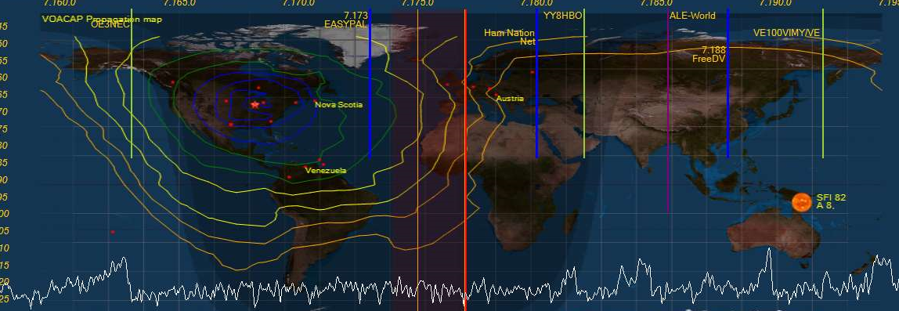

**-SWL Spotting with searchable listing window. SWL.csv file included (from eibispace.de) contains current list of SWL stations. SWL2.csv contains additional “Utility” SWL stations.  
- SWL stations appear on Panadapter as Purple Lines  
- SWL stations checked for Day and Time of operation  
- SWL searchable listing has an update button to rescan for those SWL stations currently on the air.  
- Only SWL stations currently on the air appear in the SWL search list and on the Panadapter.  
- Many Utility Stations also appear on the list: ALE, VOLMET, HFDL, DRM, STANAG,DSC,NAVTEX**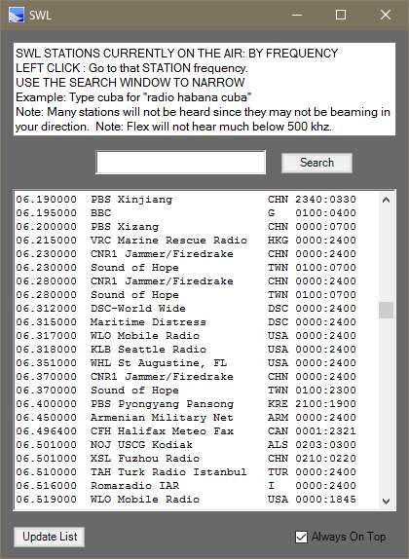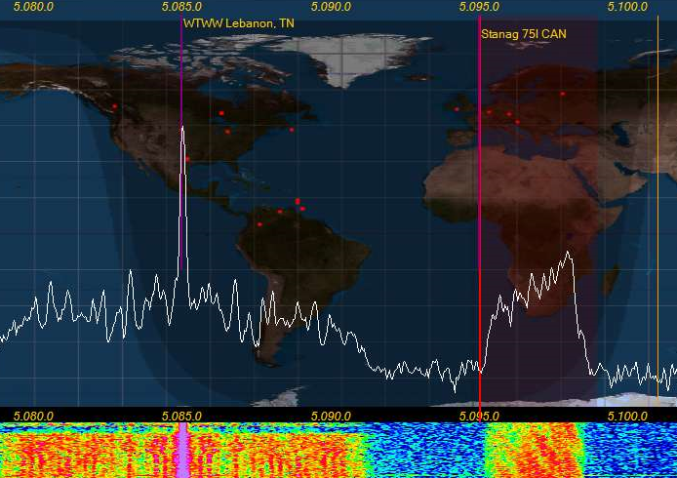

**- NIST Time Sync feature. Internet based or WWV HF radio based decoder.   
NOTE: PSDR must be launched in ADMIN mode to allow PSDR to update your PC time clock.  
- Internet: UnCheck the WWV box, Click the “Time Sync” button. Internet time servers can be jammed up, so you may need to try multiple times to get a response.  
- WWV HF: Check the WWV box, select the station from the box below (1=2.5mhz, 2=5mhz, 3=10mhz,4=15mhz). PowerSDR will narrow up and lock onto the WWV 100hz sub-carrier, which is BCD pulse width modulated. This can take up to 2 minutes to fully decode the Time and Date (because you might have just missed the start of the minute)   
NOTE: Even though the main carrier maybe stable at S9+, being an AM signal, the audio including the sub-carrier is always 1/4th the power of the carrier signal, and so subject to severe fading.**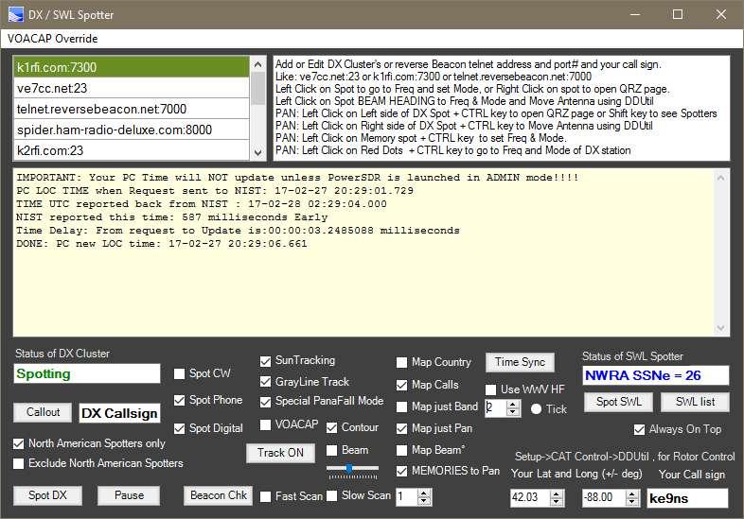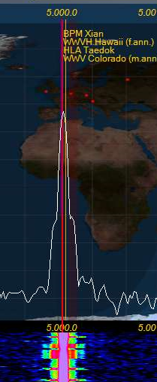

**- NCDXF/IARU Beacon scanner. Beacon Stations setup around the world time synced to allow reception reports without technically needing to decode the CW signal.  
- Fast mode jumps across all 5 stations every 10 seconds.   
- Slow mode stays on 1 selected beacon frequency and runs a full cycle listening for all stations 1 time. NOTE: World Map must be running)  
- Reports the Signal strength and noise floor dBm values on the DX spotter window and by color on the map.**

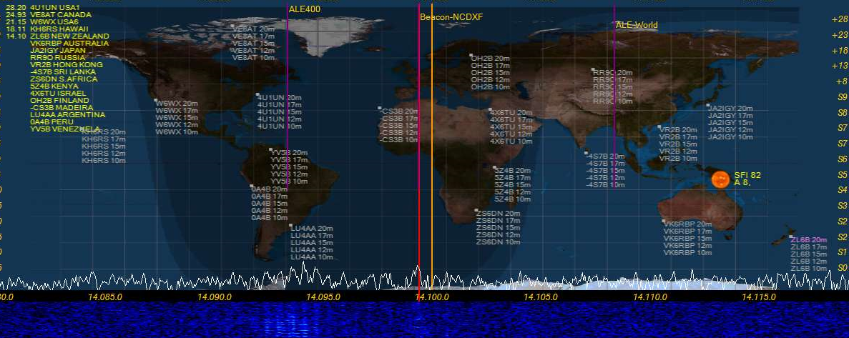

**“Wave” button** **(top of PSDR console screen):**  
- **QuickAudio Save Folder**. Creates a folder and increments the file name to automatically keep multiple audio files. File name increments after every creation.  
- **QuickAudio MP3**. Creates an MP3 file of all QuickAudio files and put it in a folder for just MP3 files  
- **MP3 Folder button**. Separate folder just for MP3 files  
- **Special QuickAudio “Record” Buttons**: Click 1 of the 4 buttons, Speak into the Mic to make your recording, Click the same button again to end the recoding and save the file under a predetermined name permanently. If you click the same button over again, you will create a new recording (losing the last recording you made)  
1) **Voice ID,** make a recording of you saying your callsign. Example: “Ke9ns for ID” . To be played if your 10 min ID Timer is set to voice ID.  
2) **CW ID,** launch the CWX panel and use a macro to create your CW ID of your callsign. To be played if your 10 min ID Timer is set to CW ID.   
3) **Reply,** make a recording of you saying your callsign. You might use this when trying to respond to a DX station. Played when clicking the **Reply** button on the PSDR console.  
4) **CQCQ** , make a recording of you calling CQ. Played when clicking the **CQCQ** button on the main PSDR console.

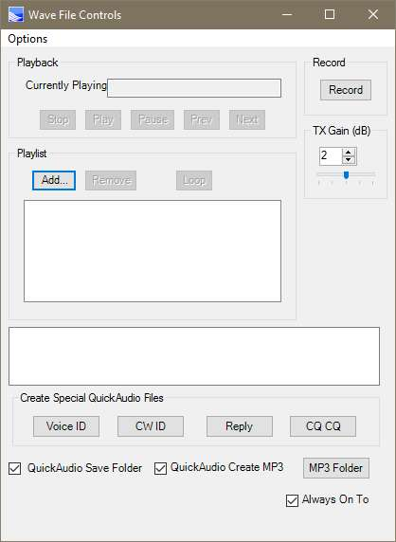

**NOTE:** All these recordings record using the current audio settings (MIC, DX, CPDR, DEXP, and TX filters). During Playback all the audio settings for the MIC are bypassed (except for your TX filter).

**“Memory” button (top of PSDR console screen):**- Drag & Drop hyperlinking, places URL into the Comments section of a memory. Right Click on memory to open up URL. Also works with files as well. You can manually add a URL directly into the comment field.  
Example: <http://ke9ns.com/flexpage.html>  
Note: Drag & Drop will not work if PowerSDR launched in ADMIN mode. ADMIN mode is needed if you wish to use the TIME SYNC function in the DX Spotter screen.  
- Open a Hyperlink: Select a Memory Row (single Left Click on any memory row), then Right Click.  
- When PSDR is in Focus, Hit ALT + M key to add current Freq, Mode, Filter on your Panadapter to Memory list  
- Weekly or Monthly recording schedule.   
- Schedule recording, records MP3 file to save space with long recordings. Example: A radio drama from the AM Broadcast band, or a Group Net.  
- Memories appear in Panadapter, when Spotter menu screen “Memories to Pan” box checked.

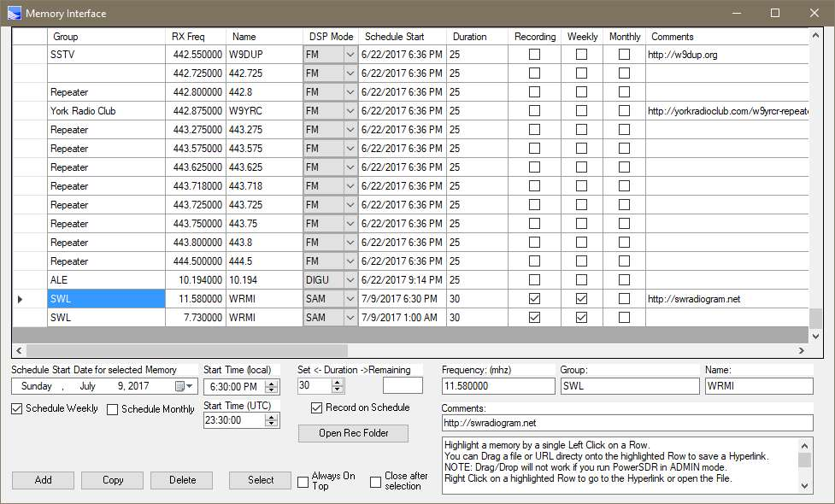

You can now enter in a Start Time (for changing frequencies and/or recordings on a time schedule), in either Local Time or UTC time. (i.e. Enter in a Local time, and you will see the UTC time below. Or Enter in a UTC time and it will show the equivalent local time above it)

**“TX WaterID” button and Callsign box (top of PSDR console screen):**Type your callsign into the box (keep the mouse inside the box while typing). Move mouse out of box and wait for box to turn GREEN. Hit the “TX WaterID” button to transmit your text into the waterfall. Other SDR radios with waterfall will see your text in their waterfall.  
- Option to transmit WaterID was wide as your current TX settings (see **Setup->Transmit->Wider WaterID**)  
- Right Click on callsign box to open up folder to drop your 100 pixels wide x 100 to 200 pixels tall x 24bit BMP files if you want to transmit BMP images. Type the name of the BMP in the callsign box (example IDIMG1.bmp so you type: IDIMG1. Leave off the BMP). BMP images are inverted: Black areas of a BMP are Bright in the water.  
- Turn OFF Waterfall Averaging by turning off the “Avg” button, or set it to “**AvgP**“ . This is mandatory on both transmit and receive of waterfall images.   
- Make sure the Panadapter/Waterfall width is not set too wide. Too wide, and the waterfall image will be very tiny.  
- Left Click on the “**Auto Wtr/Pan Lvl**” button (while Transmitting and receiving) to get the best image clarity in the waterfall.  
  
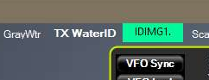 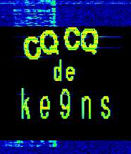 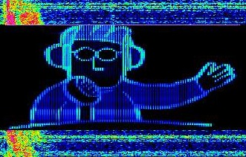

**“GrayWtr” button (top of PSDR console screen):  
Toggles the waterfall between color and grayscale. Grayscale shows finer details better (like the TX WaterID image.**  
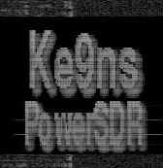

**“Scanner” button** **(top of PSDR console screen):**Display will output the Current Squelch level, and highest signal level, and any remarks  
The **Squelch pause Length** time is how long the Pause will last on a Squelch break (0=forever)

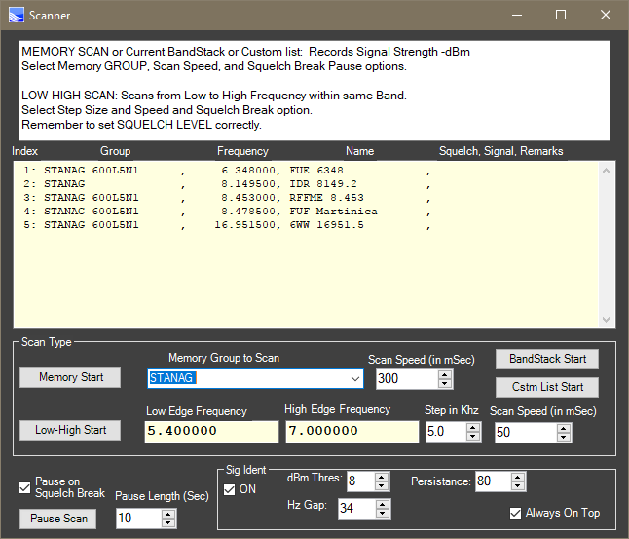

**Memory Scanner:**  
Select a “**GROUP**” of your available Memories to Scan, from the drop down list. (or a partial Group name)   
Then Select a scanning speed and optionally if you want to pause on a Squelch Break.  
Hit the **Memory Start** Button (to Start and Stop the Scan). Green when its running.  
Example: Type in a GROUP name of: **Nets**   
This will scan all **MEMORIES** that contain the word **NETS** in its **GROUP** name (it ignores case)  
  
**BandStack Scanner:**   
Go to the Band you want to Scan in.  
Hit the **BandStack Start** button to start a scan of the current BandStack memories  
  
**Custom List Scanner:**   
Click on the “**Cstm List Start**” button. This is the Folder to create and drop your text files (any name you wish)  
Select the Name of the File that contains the List of custom memories to scan (up to 50) and Click **OPEN**  
Custom Memory File Text formated as: **NAME**, **FREQUENCY** (in Mhz) , **MODE**, **FILTER**  
Example: **IARU Beacon,14.200,USB,F3**  
FILTER names: F1,F2,F3,F4,F5,F6,F7,F8,F9,F10,VAR1,VAR2 (F1 being the Upper left button)  
MODE names: LSB,USB,DSB,CWL,CWU,FM,AM,DIGU,SPEC,DIGL,SAM,DRM  
Hit the **Cstm List Start** button, and select the file name.

**Low-High Scanner:**  
Go to the Band you want to Scan in.  
The Low and High end of this band will automatically populate the Low Edge and High Edge Frequencies.  
You can optionally override the Low and High edges.  
You can optionally set to Squelch level which will pause the scan when broken.  
Hit the **Low-High Start** button to start the scan. Hit it again to restart the scan.

**Map” button (top of PSDR console screen):**Shortcut to directly turn on World Map found in Spotter menu screen.  
  
**“About” button** **(top of PSDR console screen):**  
Links to PDF’s and videos explaining the features

**PowerSDR Console Information Details (very top of PSDR console screen):**- Now displays the TURF Region programmed into your Flex Radio  
- Contact Flex Radio if you need to change your Radios Region (TURF)  
(Turf is the Region your Flex Radio is programmed for. Example: Europe, US, UK, etc.)  
  


Note: My radio’s Turf is listed as “US”

**IARU Region1 60m transmit addition:**- Firmware update to allow Region 1 60m transmit  
- Update to “Europe” turf with new Region 1 60m Band plan and Band text

**BandStack (index & size) buttons (top of PSDR console screen):**- Left Click on either Bandstack Index or Size indicators to open up free standing BandStack window.  
- Right Click on either Bandstack Index or Size indicators to open Bandstack window embedded into panadpater window.  
- ADD, SORT, and DEL buttons for up to 12 BandStack entries  
- Left Click on BandStack entry to go to Freq, Mode, Filter  
- Right Click on BandStack entry to ”LOCK” it (prevents changing or deleting)  
- “mem” indicates this BandStack is also in your “memory” list  
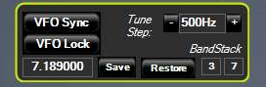 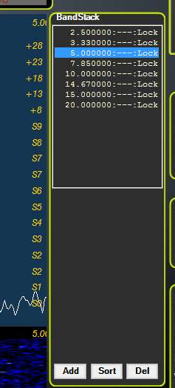

**VFOA/VFOB KHZ or MHZ frequency entry (top of PSDR console screen):**- you can now **enter KHZ frequency** for frequencies below 30mhz. (example: enter 3845 = 3.845mhz)  
- Larger Bold VFO Fonts (see Setup->Appearance->General->Bold or Outline Font)  
- Colored Rings around most off the Console Panels (see Setup->Appearance->General->Ring Color)

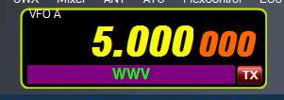 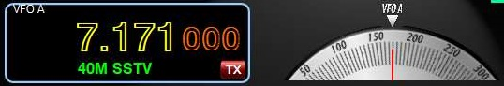

**Analog Meters (PSDR console screen):**- Left Click on RX1 meter to Toggle Between Meters: EDGE, TR7,Analog, Analog Light, Analog Dark  
- Right Click on RX1 meter to open up setup->Appearance->Meter  
- RX meter adds “Sig Pk” feature, this adds a 2nd Red Needle that hold the Peak S value for a few seconds.  
- TR7 meter option  
- 2nd TX meter “Combo”, allows for simultaneously viewing Power, SWR, ALC and live MIC levels  
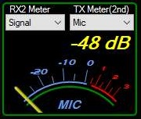 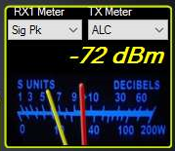 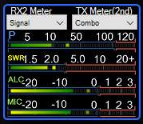  
 **Live MIC on 2nd Meter:**If you select MIC as the TX 2nd meter, it will be live if you are using a MIC attached to the Flex radio.  
(Note: Make sure VAC1 or VAC2 is not active to use Live Mic)  
 **Proper S9 Readings for HF and VHF/UHF bands**  
-73 dBm = S9 for HF bands up to 30mhz  
-93 dBm = S9 for VHF/UHF bands

**2nd TX Meter (PSDR console screen):**  
- For all Flex radios, allows you to view 2 functions simultaneously   
- see Setup->Transmit-> TX 2nd meter active  
- Click on the 2nd Meter to move it UP under the 1st meter or down to the bottom **Auto Waterfall and Auto Panadapter adjustment Feature (PSDR console screen):**- Left Click on “Auto Wtr/Pan Lvl” button to adjust the Waterfall visual display  
- Right Click on the “Auto Wtr/Pan Lvl” button to adjust the Panadapter visual display  
- Setup->Display->auto grid level & auto Wtr level sliders to adjust bias points  
**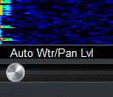  
  
MultiRX feature (PSDR console Screen):**  
- Now has the option of resetting back to VFOA when Toggled back OFF (see Setup->Display->MultiRX auto reset)

**Gridlines on the Panadater can be turned ON/OFF**- you can now turn off the Panadpater gridlines (see Setup->Display->Grid lines off

**Waterfall Move: Now the waterfall data moves with changes in Frequency (PSDR console screen):**  
- original PSDR waterfall did not move, so when you moved in frequency, the entire waterfall history was all invalid. This has now been fixed.  
- Black areas in the waterfall appear when you move frequency and there is no valid data in the waterfall.  
- Setup->Display->Enable wider waterfall (slightly more cpu but allows more sliding around frequency before needing to clear the waterfall data).  
  
**RX1 Mute checkbox (PSDR console screen):**-Allows you to mute RX1 audio while listening to RX2 audio  
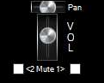

**MON button (PSDR console screen):**  
- Monitor function now works in AM/FM modes (MONpr only)  
- Click to Toggle between **MONps** (Post Processed: You hear what is transmitted by your radio), and **MONpr** (Pre Processed: You hear what is going into the Radio)

**TUN button and PULSER TUNE function (PSDR console screen):**  
- Right Click to Toggle between **TUN** (standard CW carrier TUNE), and **TUNp**  
- **TUNp** is Pulser Tune (see setup->transmit->Pulser tune->P/Sec = pulse per second  
Duty%=the off to on %amount)  
  
**MUT button and MUTE speakers only function (PSDR console screen):**  
- Right Click to Toggle between **MUT** (mute speakers and headphones), and **MUTs** (mute just speakers and not headphones).  
- Left Click to Toggle the MUT/MUTs ON/OFF  
  
**“Rec/Play ID” checkbox for MIC recordings (PSDR console screen):**- When Checked, allows you to record your MIC audio whenever you Click the “REC” button.   
- The “PLAY” button will key the transmitter and play the last recorded file.   
- If you Right Click on the “PLAY” button, you will see the list of your recorded QuickAudio files, you can manually select any file and Click OPEN. Now the “PLAY” button will play that selected file. Right Click on “PLAY” button and hit CANCEL, to go back to playing the last recorded file.  
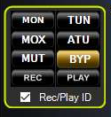  
**AF / MON slider(PSDR console screen):**- AF and MON always show current values  
- Click on “AF” or “MON” text to change function of slider

**Drive / Tune slider(PSDR console screen):**- Drive and Tune always show current values  
- Click on Drive or Tune text to change function of slider  
- Right Click on “Drive” text to toggle LOCK the Drive and Tune output values  
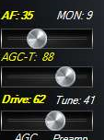

**Antenna panel (PSDR console screen left side):**  
- Added ANT icon  
- Click on panel to open up ANT selector screen (varies by Flex Model)  
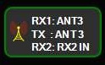

**SWL Band buttons (PSDR console screen):**- Individual 14 SWL band buttons, each with their own BandStack.   
- Bands: L/MW,120m,90m,61m,49m,41m,31m,25m,22m,19m,16m,14m,13m,11m  
- See **SWL Spotting with searchable listing window (above) for SWL search lists**

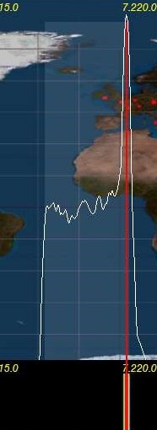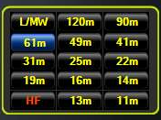

**Operating MODE (PSDR console screen):**- Left Click on **AM** button to toggle between (H3E) **AM-L**, **AM-U**, and AM  
- Left Click on **SAM** (Synchronous Receive) button to toggle between (H3E) **SAM-L**, **SM-U**, and SAM  
Normally AM & SAM transmit is DSB with a full Carrier. AM-L or AM-U is SSB with a Full Carrier. Since ~66% of the power of a fully modulated AM signal goes into the Carrier, about 33% remains for the Sidebands (or 16% for each Sideband of a standard DSB AM signal), so SSB-AM keeps your power at 33%.  
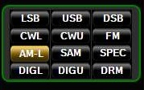

**Space Weather data (PSDR console screen):**- Click to Toggle On/Off  
- **ss:** Official Sun Spot# from sidc.oma.be updated hourly (determined by optical observation of the sun)  
- **ef:** Effective Sun Spot# from nwra.com updated hourly (determined by radio observation of mid latitudes)  
- Space weather indices: SFI, A, K, and storm data from NOAA.com

**Temp & Volts (PSDR console screen):**- Model Flex-3000 and Flex-5000 only  
- Click to Toggle On/Off (click on temp toggles between C and F)  
- Shows PA temp/volts (updates at same rate as CPU% found in setup->display) (varies by Flex model)

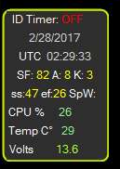

**ID Timer 10 minute (PSDR console screen):**  
- Left Click to Toggle ON (synced to next minute),  
- Left click again ON (synced to next 10 min increment 0,10,20,30,40,50), then one more click to OFF  
- Right Click to Toggle between: Pop-Up **Message box**, **WaterID**, **VoiceID**, **CWID** (see Wave screen for recording **VoiceID** and **CWID** audio files)  
- Pop-Up Message box has option for 5 second timeout, or stay on screen until you click on it to close.  
- Position of Message box is remembered so you can place it on a 2nd monitor  
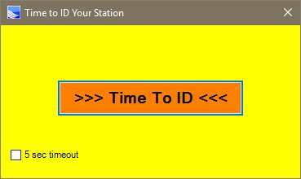  
  
**Time Out Timer (setup->General->Hardware Config->Time-Out Timer):**  
- Check to activate feature.  
- When Radio is transmitting the timer counts down to 0  
- If Count reaches 0, the Radio turns OFF and Pop-Up message box must be cleared.

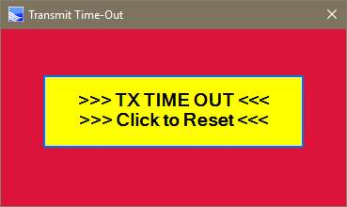

**PAN: VFOA Slider feature (PSDR console screen):**  
- Click PAN: button (turns RED) to Toggle VFOA Slide function, allows VFOA to slide around Panadapter screen while screen does not move.  
- To reset, turn off PAN (turns White), then click on “Center” button

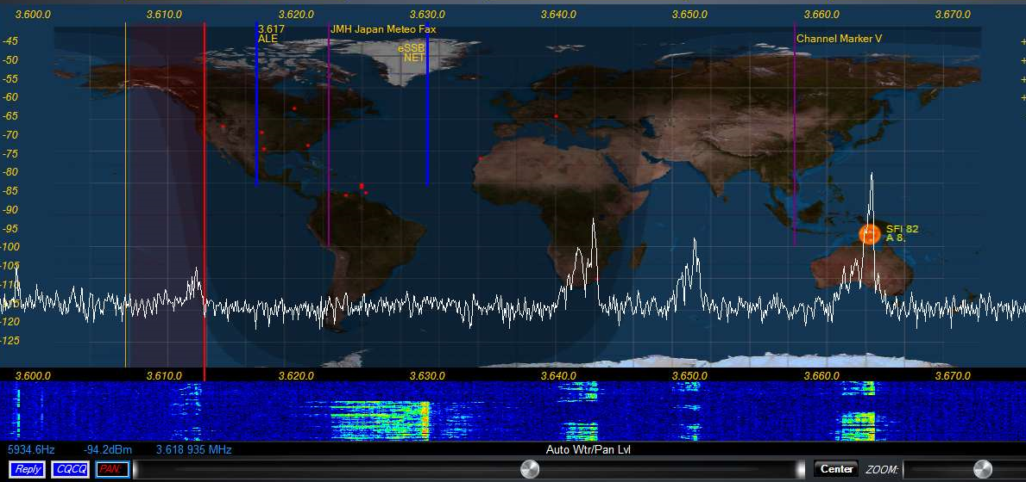

**ZOOM: feature (PSDR console screen):**  
- Left Click to Toggle Panadapter signal enlarger feature ON/OFF (Zoom in the vertical direction only)  
- Right Click to turn ON extra Panadapter window showing your BandPass area.  
 **Transmit Profile (PSDR console screen):**- Low / High transmit profile settings viewable from main console window  
- Right Click on current transmit profile to open up setup->transmit   
- TX profile selectable from the DIGU and DIGL panel  
 **Relay / CQCQ buttons (PSDR console screen):**  
- Click to automatically MOX your radio and transmit prerecorded audio files  
 (see Wave screen for recording Reply and CQCQ audio files)  
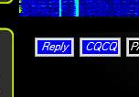  
 **RX2 PanaFall Mode (PSDR console screen):**- RX2 can now be viewed in Panafall mode, just like RX1  
 **RX1 Continuum waterfall Mode (PSDR console screen):**- Special waterfall screen that shows dBm vs time

**VAC1/VAC2 buttons (PSDR console screen):**  
- Right Click on panel to open up setup->Audio->VAC1/VAC2 panel directly

**NR/ANL/NB/TNF buttons (PSDR console screen):**  
- Right Click on panel to open up setup->DSP->Options panel directly  
- Reset button on the Options panel (if you mess up the settings)  
  
**CWX Panel:**- Added CW Key Polling option. Hit your CW key or paddle to stop any macro transmission  
- Larger Macro text size  
- Sync CW speed to CW panel on main PSDR console screen  
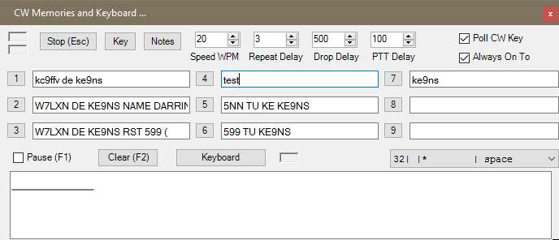  
  
**Flex Control Knob:**- Alternate Tune Step Rate FlexControl Knobs (see setup->General->User Interface)  
**PowerMate Knob:**- Built in PowerMate Knob driver  
- Alternate Tune Step Rate for both Powermate Knobs (see setup->General->User Interface)  
- Seperate Alt Tune Step ON checkbox for either PowerMate or FlexControl  
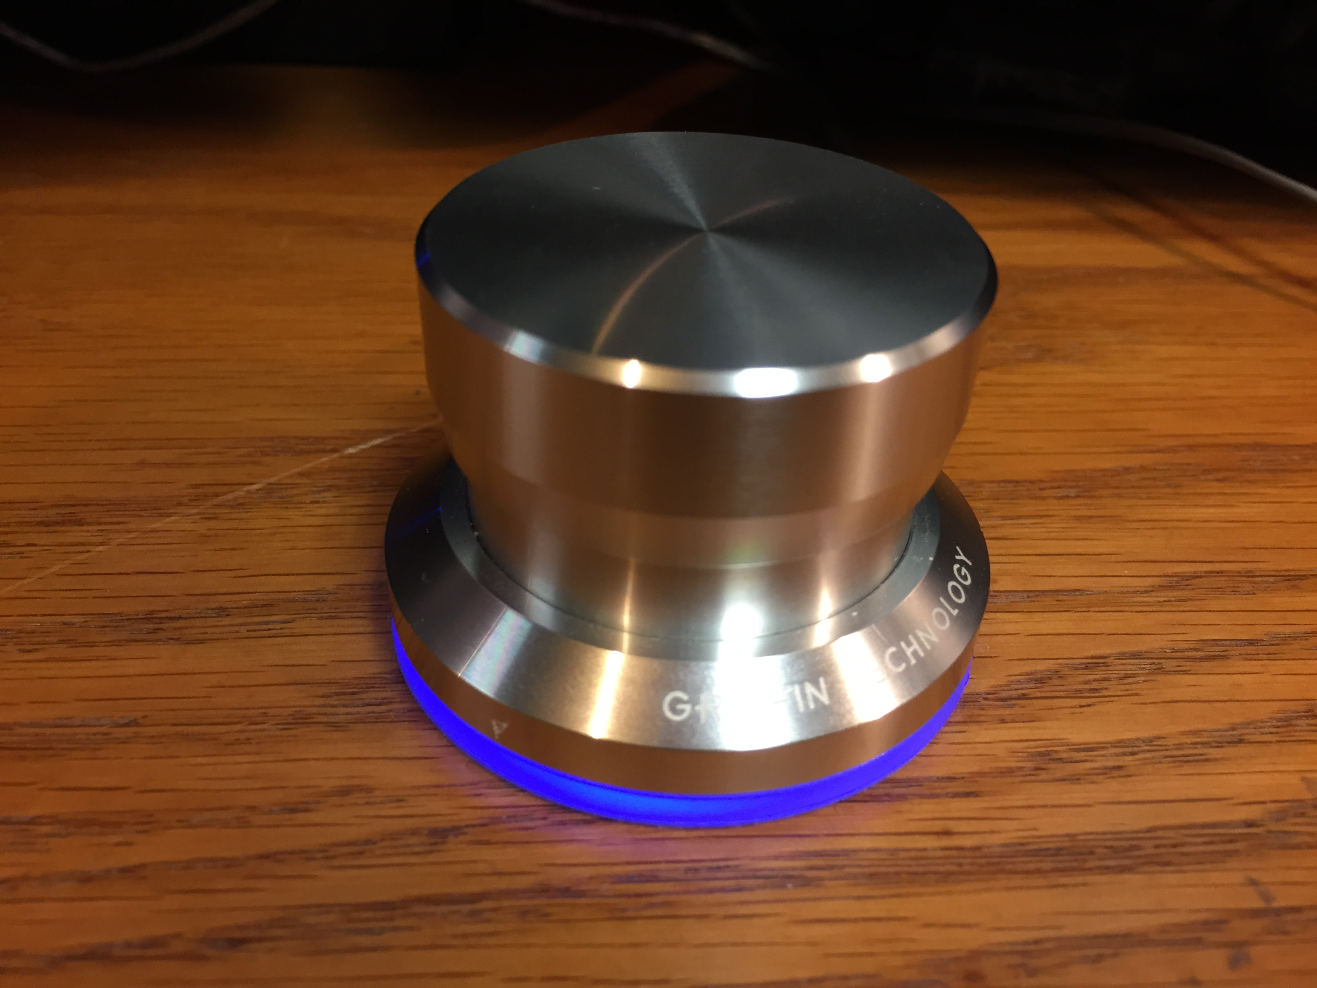  
  
**DJ Console:**  
- Incorporated DH1TW code for interfacing DJ Console controllers.  
- See setup->General->User Interface  
- Fixed A>B, B>A, A<>B functions  
  
**HTTP Server (see image below):**  
- Setup your Router “Port Forward” to pass the Port# you select.  
- get an No-IP.com account which is a permanent URL linked back to your home IP address  
- setup your router to update your No-Ip.com account (usually under apps and gaming)  
- Now if you type in your no-ip.com URL:port# from a web browser you will see your Panadapter  
- Full Console: when checked, will show the Entire PowerSDR console over the internet (including any open windows sitting on top of the PowerSDR console)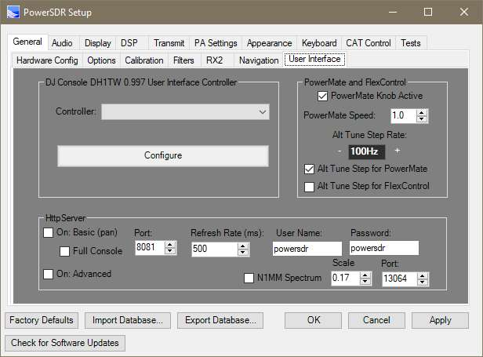  
  
**Output Panadapter to N1MM+ logger Spectrum window (setup->General->User Interface->N1MM)**  
- The only caveat is that the PowerSDR Panadapter or Panafall screen needs to be up and running in order for it to provide data to N1MM+ spectrum screen.  
- Right Click on the N1MM spectrum screen and select your callsign as the data stream.  
- N1MM displays spots on this window.  
- When N1MM properly configured, clicking on this screen will change the TX/RX freq of PowerSDR.  
